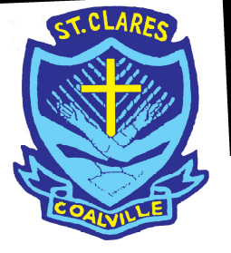
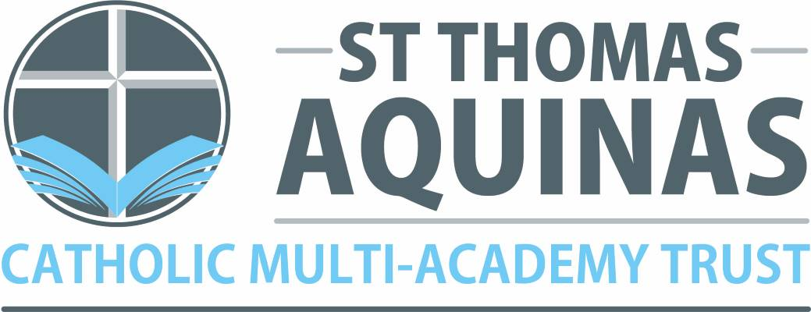

St. Clare’s Primary School –
A Catholic Voluntary Academy
Dear Parents and Carers,
We are delighted that you have chosen St Clare’s as your child’s primary school.
Normally at this time, we would be sending you a list of events that you and your child could attend in order to get to know the staff and the school. Sadly, that’s not possible at the moment, but we are working on other ways to help you and your child feel a part of the school community. There is a lot of information included with this letter:
· A data form which must be completed with details about family contacts, medical and dietary needs and other important information. We have enclosed a stamped addressed envelope for you so would be grateful if you can send it back as soon as possible.
· NHS information about medical appointments that will happen when your child starts school.
· School uniform requirements and our approved suppliers.
· A getting ready for school checklist so that you can best prepare your child for school over the summer.
· Our parent information booklet which covers frequently asked questions.
· A pupil booklet to share with your child and images of the classroom and other key areas around the school.
In addition, we are creating a page on our website especially for our new Reception families: www.st-clares.leics.sch.uk click on EYFS 2020/21 new starters.
We are currently working on this; we will be adding information over the following weeks.
On this page, you will find additional information:
· A parents’ meeting presentation
· Information about opportunities for teachers, parents and children to meet in person
· Video messages from key staff members
· Additional useful information leaflets
Please note that all dates are provisional and may need to change subject to government advice. Dates of meetings and school start dates will be confirmed nearer the time.
If you have any further questions, please contact the school office.
We look forward to welcoming you to St Clare’s in person.
Yours sincerely,
Mrs Palmer and Mrs Lees
Reception Teachers

