Computing | Year 4 | Word Processing | Transform a Layout | Lesson 5

How to Make Cupcakes

Ingredients
250g (8oz) unsalted butter, softened 250g (8oz) caster sugar
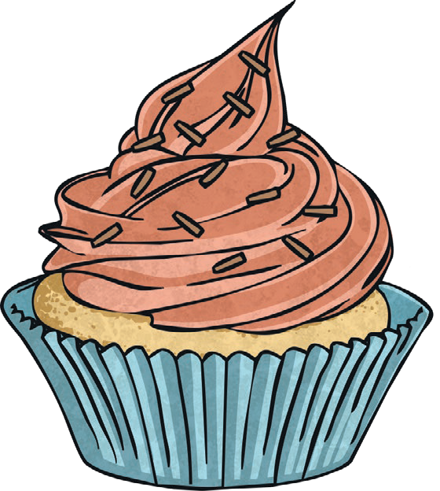
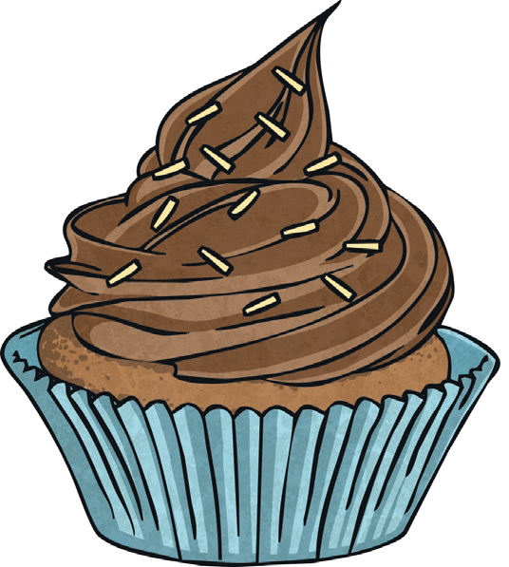
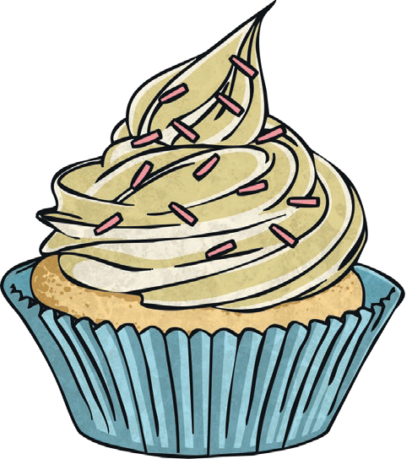
250g (8oz) self-raising flour Pinch of salt
4 medium eggs

Equipment
A bowl A whisk
12 paper cases A spoon
A muffin tin

Method
Preheat the oven to 190°C or gas mark 5. Beat the butter in a bowl until softened.
Add the sugar, flour, salt, eggs and milk and whisk until you have a smooth mixture. Divide the mixture between all the paper cases with a spoon.
Place the tin in the oven and bake for 15-18 minutes or until the cakes are golden brown.
Remove the tins from the oven. Leave to cool in the tins for a few minutes, then move them onto a wire cooling rack.

