Things that puzzled you/ Questions you have | What it reminds you of  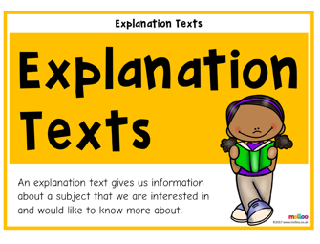
Your favourite section and why  Favourite words/sentences and why | What you noticed about the report  What surprised you

