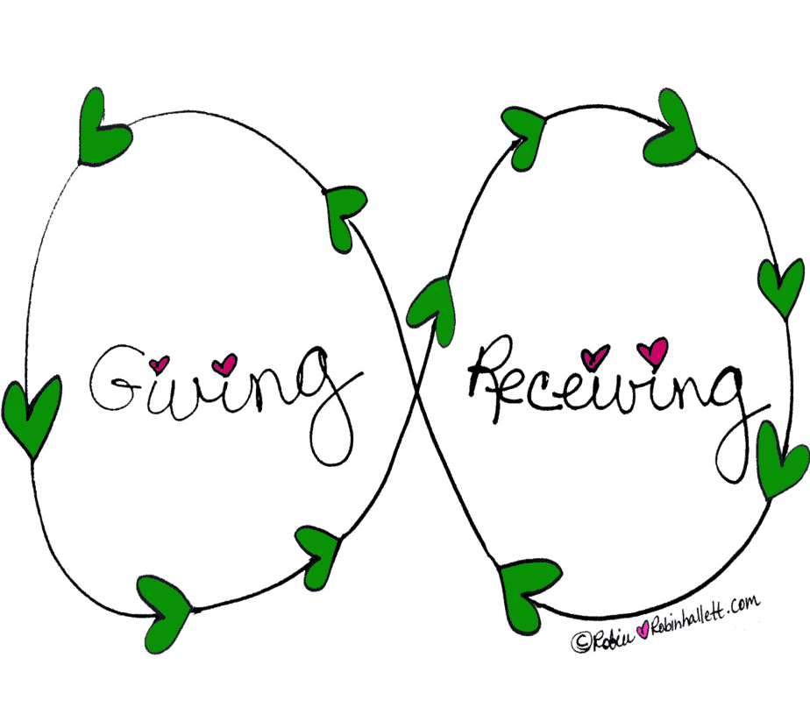





What’s more important - giving or receiving?

What’s more important - giving or receiving?

What’s more important - giving or receiving?

What’s more important - giving or receiving?