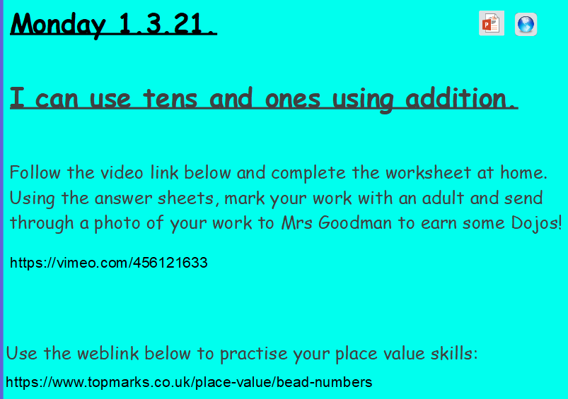

<https://vimeo.com/456121633>

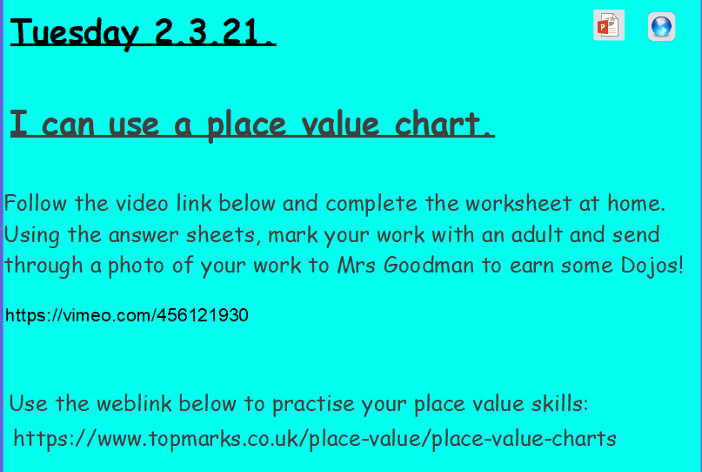

<https://vimeo.com/456121930>

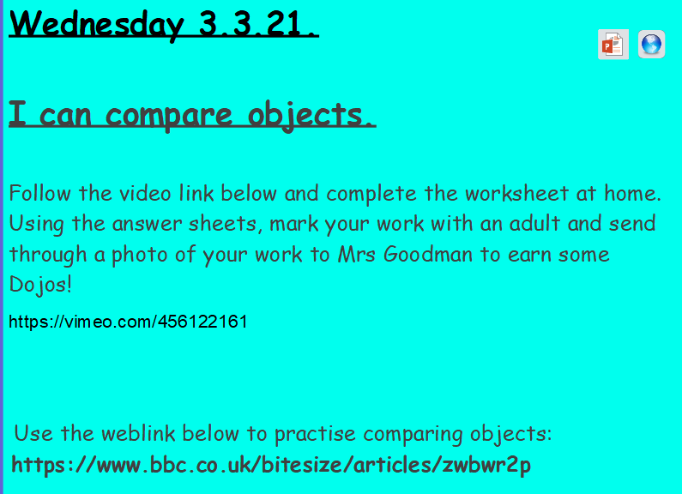

<https://vimeo.com/456122161>

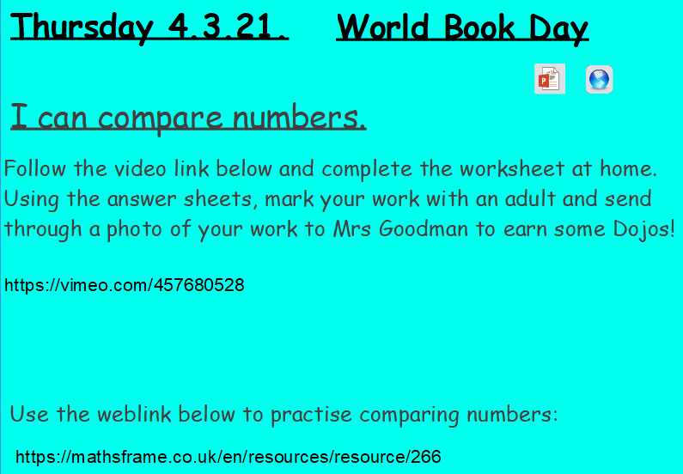

<https://vimeo.com/457680528>

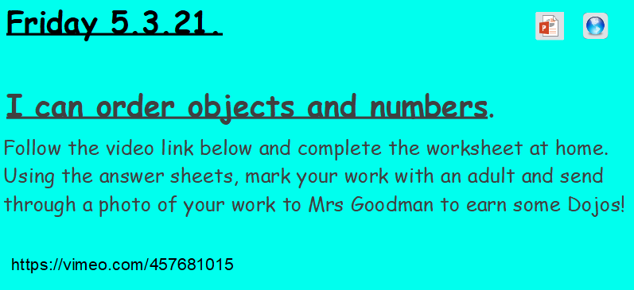

<https://vimeo.com/457681015>