Story Spuds!



As we aren’t dressing up ourselves this year for World Book Day, we thought we’d get costume-creative in a different way!

We are challenging you all to create a ‘story spud’ – a potato decorated as a character from your favourite book. It can be any size and can include any number of potatoes, as long as it represents a character from a book!

When you’ve finished your design, send a picture to your class teacher via Class Dojo. The best design will be judged by different adults in the school and the winner will receive a book themed prize! You’ve got to be in it to win it!

So, grab yourself some spuds and let your imagination run wild. We can’t wait to see what you come up with!

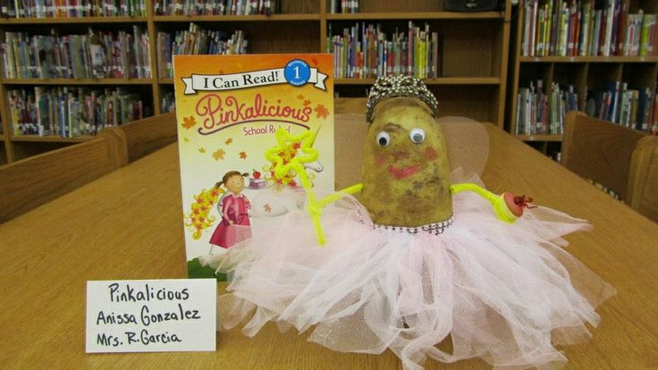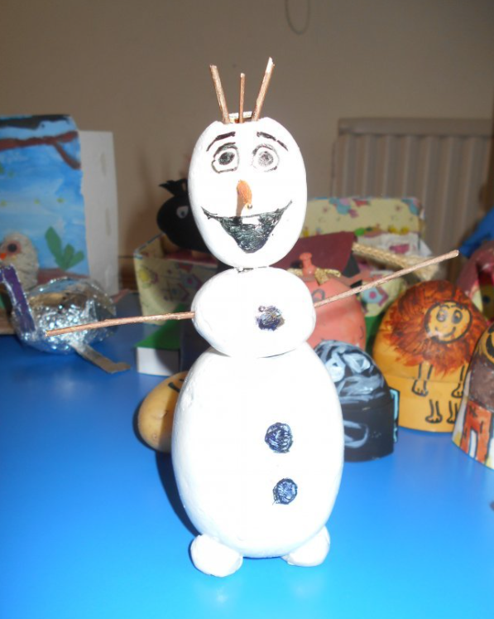Some ideas for inspiration!

