Welcome to St. Clare’s Primary School



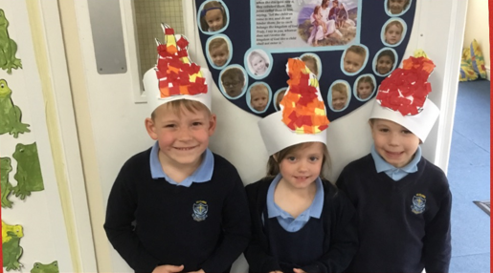

EYFS Parents’ Information Booklet

**WELCOME TO EYFS**

Beginning school is a major event in the life of a four year old and it won’t be long before your child will be starting with us at St. Clare’s Primary School. There are lots of new things to learn and of course you will want to ensure that your child is well prepared for this important event. We aim to make it a happy and memorable experience. We hope that this booklet will provide some useful information that will help your child settle quickly into school.

**Contents**

|  |  |
| --- | --- |
| Page 3 | General contact information |
| Page 4 | Meet the staff |
| Page 5 | Parents as partners |
| Page 6 | The School Day |
| Page 7 | Daily life |
| Page 8 | Induction Dates |
| Page 9 | Learning in EYFS |
| Page 10- 11 | The EYFS Curriculum |
| Page 12 | Outdoor Learning |
| Page 13 | List of items to bring to school |
| Page 14 - 17 | Helping prepare your child for school |

**General Information**

Our contact details are:

St. Clare’s Primary School (A Catholic Voluntary Academy)

Convent Drive

Coalville

Leicestershire

LE37 3SF

**Telephone:** 01530 837747

**Email: office@st-clares.leics.sch.uk**

**School Website:** [**www.st-clares.leics.sch.uk**](http://www.st-clares.leics.sch.uk)

**Head Teacher:** Mrs. J. Beer

**Foundation Teachers:** Mrs. Liddle and Mrs. Palmer

**Chair of Governors:** Mr. K. McHugh

**Meet the Staff**

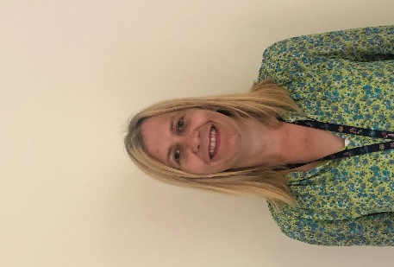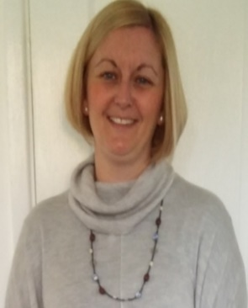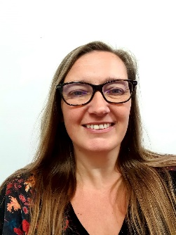

**Mrs. Liddle**

**Deputy Headteacher/**

**EYFS Teacher**

**(Wed – Fri)**

**Mrs. Palmer**

**EYFS Teacher**

**(Mon & Tues)**

**Mrs. Beer**

**Headteacher**

**Mrs. Lees**

**SENCO**

**There may be additional adults in the class.**

**Mrs Glauds- (Teaching Assistant)**

**Parents as Partners**

We recognise the importance of parents and carers in a child’s developing stages. As a primary care provider, you are your child’s first educators and we greatly value any input, opinions and information you can share with us about your child’s learning and progress.

You will also receive a reading diary. We encourage you to write about how your child is getting on with their reading and share any additional information that you feel is appropriate for us to know.

We also welcome parent helpers in our school. If you think you can spend some time with us, just enquire about it once we’ve all settled into the autumn term.

**The School Day**

**Collecting your child**

At the end of the school day you will be able to come onto the Reception playground at 3.15pm. We will dismiss your child from the classroom door to the adult that is collecting them.

It is vital that you inform us if someone different is collecting your child. If we are unsure, we will have to contact you before we can let your child leave the premises. We hope that you understand that the welfare of your child is of the utmost importance for us and we appreciate your help in ensuring all children remain safe in school.

**Morning Procedures**

Children come into school via the main car park gate. You follow the yellow path and go through to the EYFS playground.

You will then need to take your children to the classroom where you will be met by your child’s teacher. The playground gate will open at 8.45am and will closes at 9:05 a.m.

**Daily Life at Saint Clare’s.**

**Water, Fruit and Milk**

Children are offered a piece of fresh fruit at snack time. You do not need to send a snack for your child.

We do encourage your children to bring in a water bottle every day. **Your child’s water bottle should be clearly labelled and contain only water**.

Children are also offered milk to drink each day which is free until their 5th birthday. Please see the enclosed letter to register your child for free milk.

**School Dinners**

Our chef, Mrs. Palmer prepares hot meals for us every day in our school kitchen. The menu for each week is posted on the school website. Alternatively, your child can bring in a packed lunch.

School dinners and packed lunches are served in the hall. If your child has any special dietary requirements, please inform your class teacher as soon as possible.

School dinners are **free** for all children in EYFS, Year 1 and Year 2.

|  |  |  |
| --- | --- | --- |
|  | Group A | Group B |
| **Parent meetings in school**  We will send you an appointment nearer to the time. | Thursday 31st August  AFTERNOON ONLY-from 1pm-3.15pm | Thursday 31st August  AFTERNOON ONLY-from 1pm-3.15pm |
| Induction day 1  9:00 a.m. – Midday | Friday 1st September | Monday 4th September |
| Induction day 2  9:00 a.m. – 1.00pm | Tuesday 5th September  STAY FOR LUNCH | Wednesday 6th September  STAY FOR LUNCH |
| First full day for all children | Thursday 7th September | |

**Induction Programme 2023**

**Learning in the EYFS**

EYFS is where the excitement begins! The children learn together in an environment which is developed around the children’s interests. We pride ourselves on being an exciting and engaging place to be – encouraging our children to be independent learners through a range of practical activities. We follow a thematic curriculum which allows us to be creative with our lessons and let the children lead their own learning.

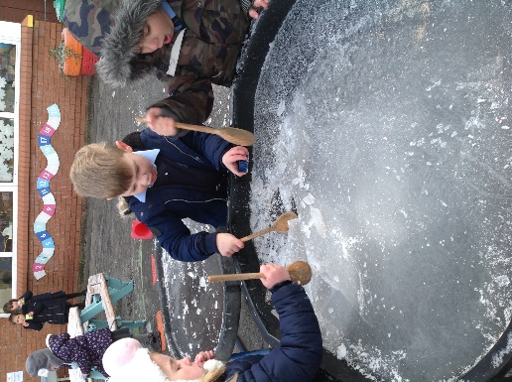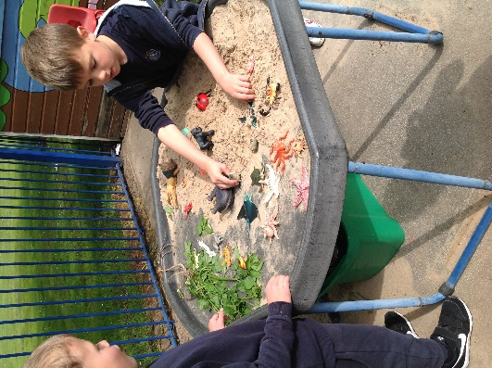

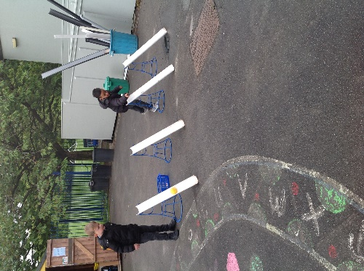

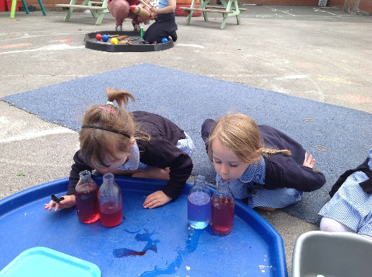

As our EYFS children enter the classroom, they learn primarily through a variety of play and real-life experiences. Our teaching is delivered though carefully planned tasks and guided key tasks. The children access their environment freely; however, they understand they must complete ‘certain challenges’ throughout the week which scaffold and extend their learning. Their development is tracked carefully.

**The EYFS Curriculum**

In EYFS, the children follow the Early Years Foundation Stage Framework (EYFS). This curriculum is based upon four themes and principles.

**The Unique Child** – We understand that every child is an individual child who is capable in their own right. The holistic child has a variety of needs that need meeting over their time in the EYFS.

**Positive Relationships** – Social interaction is key to children’s development. Children become strong, independent learners; as well as scaffolding their learning through positive social interaction.

**Enabling environments** - Providing a safe, secure and stimulating base for your children is key to their development. The framework allows for experiences that responds to the child’s individual needs / interests; as well as developing a string partnership between practitioners, parents and carers.

**Learning and development** – Children develop and learn in different ways. The framework covers the education and care of all children in early years provision, including children with special education needs and disabilities.

The EYFS Curriculum has also identified the following **characteristics for effective learning** and these are promoted and encouraged throughout the foundation curriculum here at St Clare’s:

* **Playing and exploring (engagement)**
* **Active learning (motivation)**
* **Creating and thinking critically (thinking)**

**Early Learning Goals**

The early years curriculum, taken from the foundation stage framework, is organised into seven areas of learning. This framework provides the basis of how we structure the setting and the activities and opportunities we provide, as well as how we assess your child’s development. For each of these areas your child will have an ‘Early Learning Goal’ to work towards.

****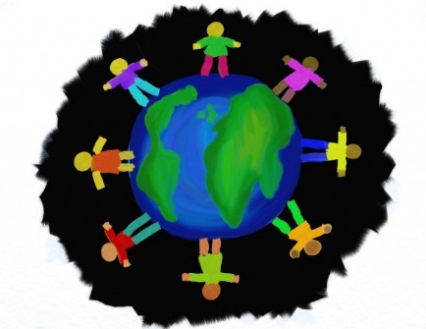**Prime areas of learning**

* Communication and language
* Personal, social and emotional development
* Physical development 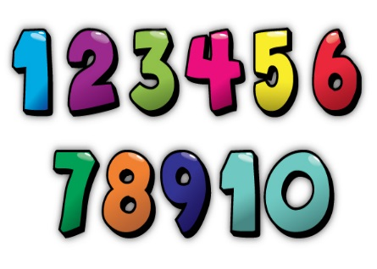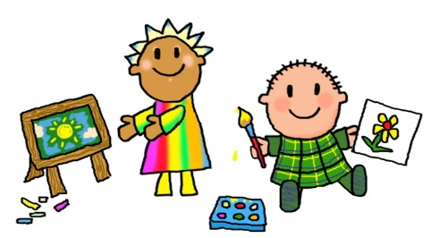

**Specific areas of learning**

* Literacy
* Problem solving, numeracy and reasoning
* Understanding the world
* Expressive arts and design

We teach all these areas of learning through a variety of topics and themes to ensure that learning is enjoyable, relevant and interrelated; including taking into account children’s interests.

**Outdoor learning**

At St. Clare’s, we have a strong emphasis on outdoor learning in all areas of the curriculum. Being outdoors, offers opportunities for doing things in different ways and on different scales. It gives children first-hand contact with weather, seasons and the natural world and offers children the freedom to explore, use their senses and be physically active.

The outdoors is open to children throughout the day and therefore it is really important that they are dressed suitably for all weathers.

In cold weather, the children should bring hats, gloves and scarves with their names on them. We do ask that you bring a named pair of wellies for your child. These will stay on the welly rack by the classroom door. In wet weather please send your child in a waterproof coat because we will still go outside and enjoy the rain.

During the summer months, suntan lotion should be applied before school and children should bring sunhats.

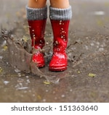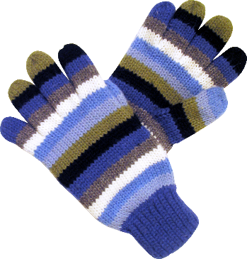

**List of items to bring to school**

* 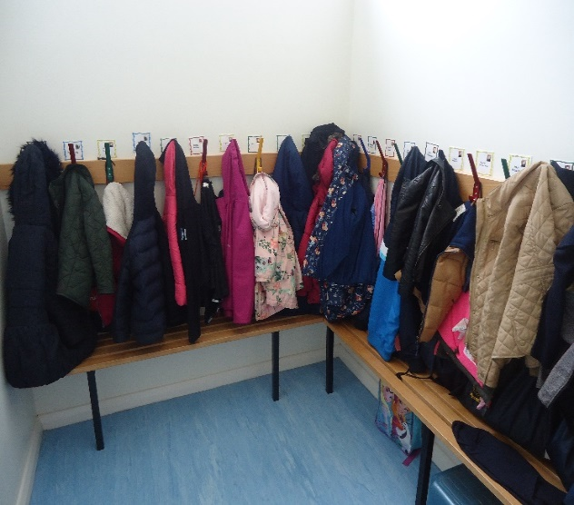Named black slip-on/Velcro plimsolls. We change our shoes to keep our classroom clean.
* Named wellies – we play outside in all weathers!
* Named suitable coats – nothing too special as it is likely to get sandy, muddy or wet.
* Named hats, scarves and gloves.
* 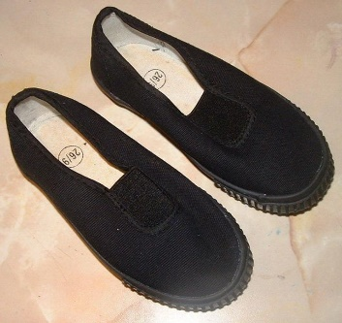Named sun hats
* 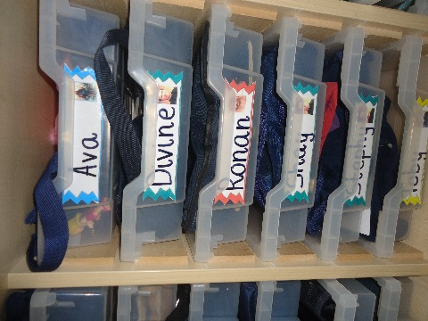Named water bottle containing water
* Named bag for books. Branded Saint Clare’s book bags are available to purchase from the school office. Reading books and reading diaries will be provided by school.

**In EYFS, children come to school on P.E. days in their P.E. kit and wearing trainers. We will let you know P.E. day at the beginning of the Advent term.**

**Helping prepare your child for school**

Here at St Clare’s, we go to great lengths to help your child be prepared for their next stage of learning; as well as developing the confidence and skills to be an independent learner.

In preparation for school, here are some of the things you can do with your child to help them develop the basic skills on the road towards their Early Learning Goals.

**Listening**

* Show your child how to be a good listener by listening to them and others
* Be patient – don’t interrupt or finish their sentences for them
* Give them your full attention when they are speaking, showing them eye contact and good body language.
* Respond to what they are saying by asking questions or ask about their opinions
* Listen to your child reading.

**Speaking**

* Speak clearly and confidently
* Model using the right words and set an example
* Speak in full sentences
* Use clear, simple directions for tasks and behaviours
* Engage in discussions with your child and allow them to speak without being interrupted
* Ask for their opinions
* Tell them about your day and ask about theirs.

**Number skills**

* Count daily with your child
* Count objects, actions, numbers and a range of things
* Identify numbers wherever you go – a neighbour’s house number or the number on a bus.
* Help children putting numbers in order
* Let children help with the tidying and sorting. Can they sort the DVDs by colour?
* Identify shapes around the home
* Use fingers to represent number.

**Extending their learning**

* Talk about the world around them and encourage them to ask questions.
* Go to local museums, parks, wildlife reserves and into nature.
* Get to know what your child is learning. We will send home information about what the children are learning about in class.
* Take time to listen to your child and explain things carefully, developing their understanding and vocabulary.

**Organisation**

* Children like routine so set regular times for bed, getting up, meals and family time.
* Under 5s need up to 15 hours and primary children 10 hours sleep a night
* Check your child has their name in everything before they bring it, this helps them to be organised at school
* Help your child remember to bring everything – book bag, water bottle, reading book etc
* Help your child to have all the equipment they need for learning
* Let your child take hold of their own things on the way to school – they will know where to put books, bottles and bags
* Let your children help you at home with the cooking, cleaning and shopping – they relish an opportunity to feel useful!
* Be patient when your child is helping
* Lay your child’s clothes out in the correct order each morning so they can dress themselves.
* Children are expected to toilet themselves once they begin the Foundation Stage.

**Behaviour**

* Agree clear and realistic rules – and stick to them
* Give your child boundaries so they know what is expected of them
* Encourage your child to always say ‘please’ and ‘thank you’
* Support the school rules and behaviour systems

**Writing**

* Encourage your child to mark make without feeling pressured
* Get your children colourful pens, gel pens and exciting new tools to encourage them to mark make
* Let children write their names on cards or letters
* If your child is already writing with a pen or pencil, support their pencil grip so they do not develop a bad habit.

**Tips for preparing your child for school**

Your child will be in a class of 30 children. It will make starting school much easier and happier if they are independent and can do many things for themselves.

**What should he / she be able to do?**

Can he/she …

* Dress and undress themselves?
* Use the toilet independently and ask to go there?
* Tidy up after himself/herself?
* Recognise their own name?
* Feed himself/herself?
* Share toys and equipment?
* Handle a pencil?
* Sing some nursery rhymes?
* Practise counting to 10?
* Listen well and follow simple instructions?

**How can I help my child prepare for school?**

* Encourage them to be as independent as possible even if it takes far longer for them to get ready.
* Get them used to a routine of reasonably early to bed and up early enough for you and your child to have a stress free time getting ready for school.
* Never threaten them with school! Be positive. Show it to them as an enjoyable experience.

**What can I do with my child before they start school?**

* Give your child as many varied experiences as possible: drawing, painting, cooking, singing, making models, playing games, jigsaws etc.
* Get them used to: pencils, crayons, felt pens, chalks, paints, play dough.
* Scissors – teach your child to hold and use a pair of scissors independently i.e. cutting pictures out of a toy magazine.
* Share stories, books and rhymes. Read to them.
* Count everything and share things out.
* Use lots of one to one correspondence – cup, plate, knife, fork and spoon for each person.
* Talk to them all the time. Name familiar things and discuss what they see around them and what things are for. Talk about what you see when you are out and about. Watch people work and discuss what they are doing.



